**2018 Secondary School Clay Target Competition Overall Results**

**ERNIE McCONNELL FAMILY CUP – Points Score for Day**

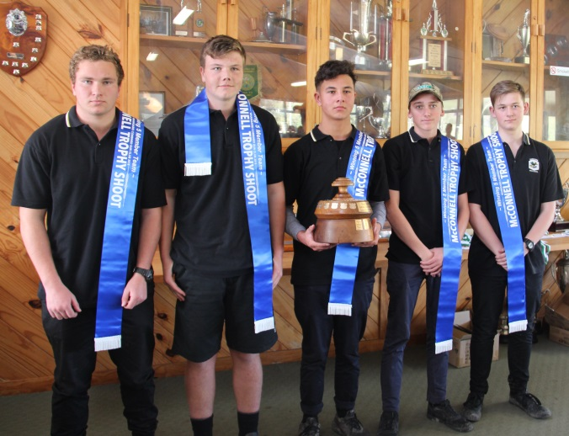

**Tauraroa Area School - Whatitiri 93**

**Far North Inter School Trap Shooting Cup**

**Kaitaia School**

**Northland Secondary Schools Clay Target Ass. Cup for Girls**

**Carlisa McCarroll 81**

**SKEET SINGLE OPEN**

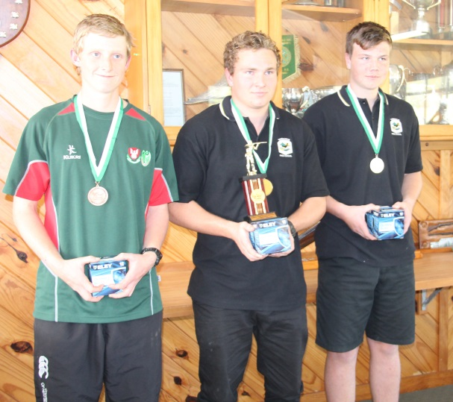

**1st Blair Thomas 46**

**2nd Skye Martinac 44**

**3rd Blake Carr 41**

**SKEET PAIRS**

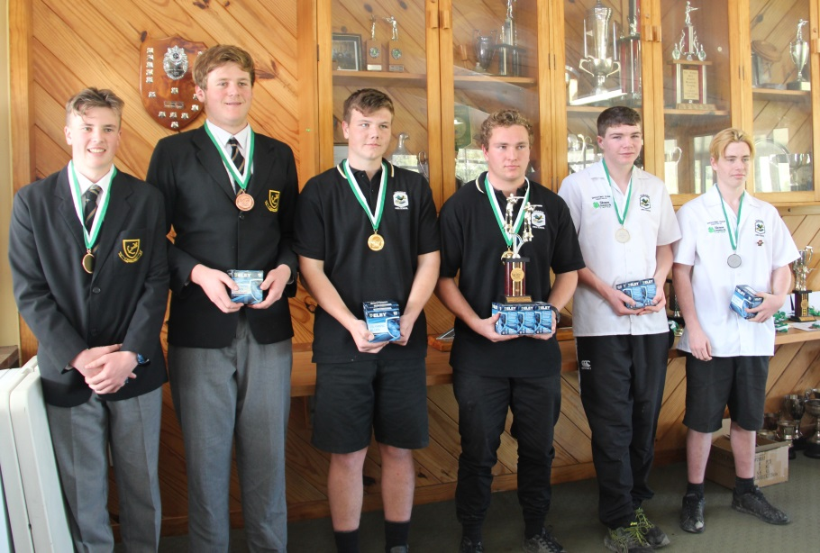

**1st Skye Martinac/Blair Thomas 90**

**2nd Toby Lincoln/Max Woolhouse 78**

**3rd Jacob Kennedy/Ethan Hare 74**

**TEAMS EVENT**

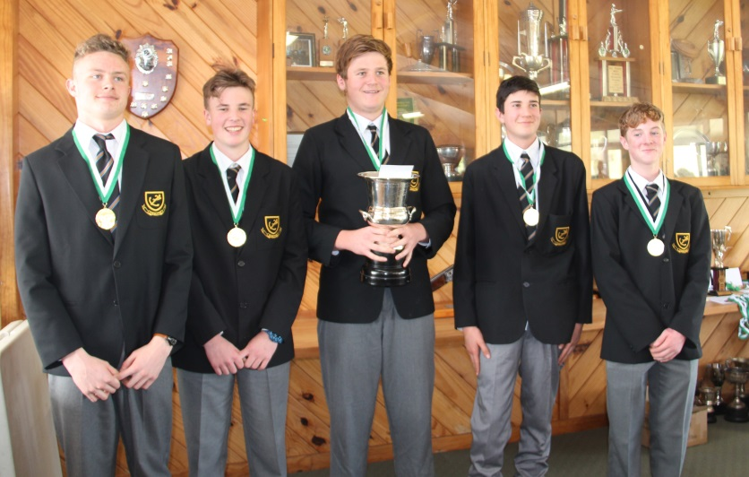

**Whangarei Boys High Team**

**1st Whangarei Boys High 2024 points**

**2nd Tauraroa Area School – (Whatitiri) 1947 points**

**3rd Tauraroa Area School (Whangarei Combined) 1900 points**

**POINTS SCORE OPEN**

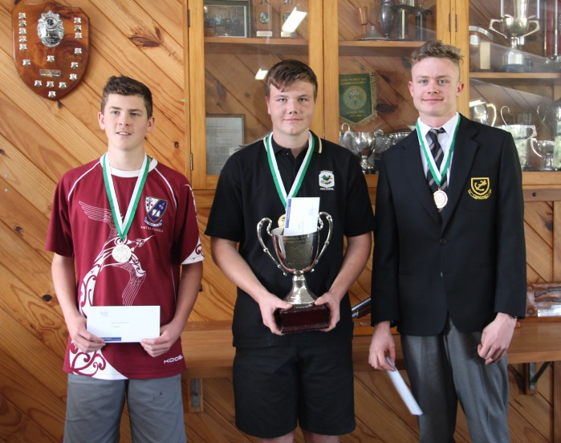**1st Skye Martinac 287**

**2nd Taz Snelling 271**

**3rd William Hamlin 268**

**SINGLE RISE OPEN**

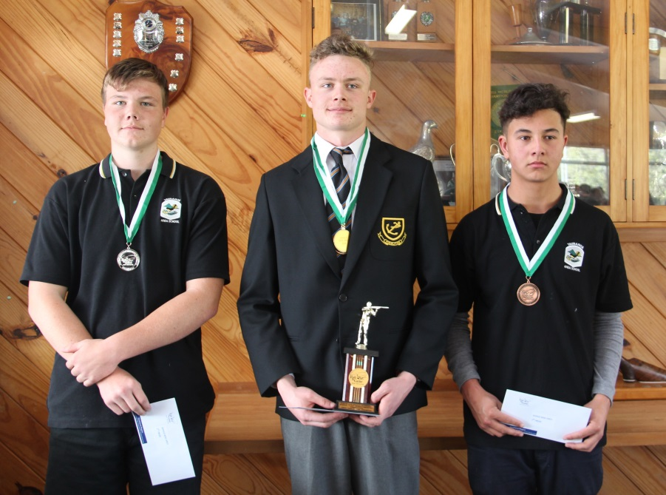

**1st William Hamlin 94**

**2nd Skye Martinac 94**

**3rd Zion O’Leary93**

**SINGLE BARREL GIRLS – Sponsored by McCoy & Thomas**

**1st Carlisa McCarroll 59**

**2nd Keely McCollum** **56**

**3rd Mikayla Gardner 55**

**SINGLE BARREL BOYS – Sponsored by McCoy & Thomas**

**1st William Hamlin 68**

**2nd Skye Martinac 66**

**3rd Zion O’Leary 62**

**HIGH OVERALL GUN FOR 2018 – Girls**

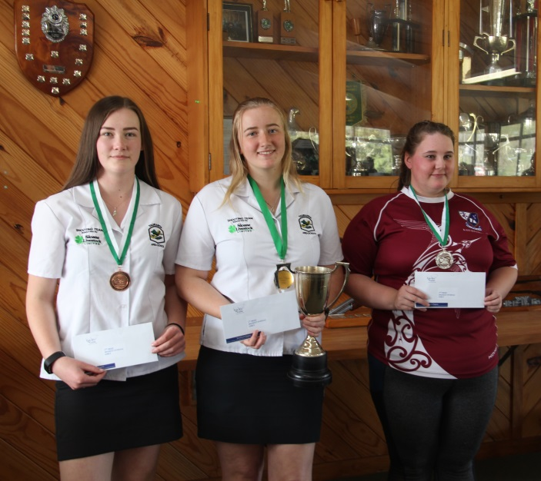

**1st Carlisa McCarroll 402**

**2nd Mikayla Gardner 396**

**3rd Keely McCollum 380**

**HIGH OVERALL GUN FOR 2018 – Boys**

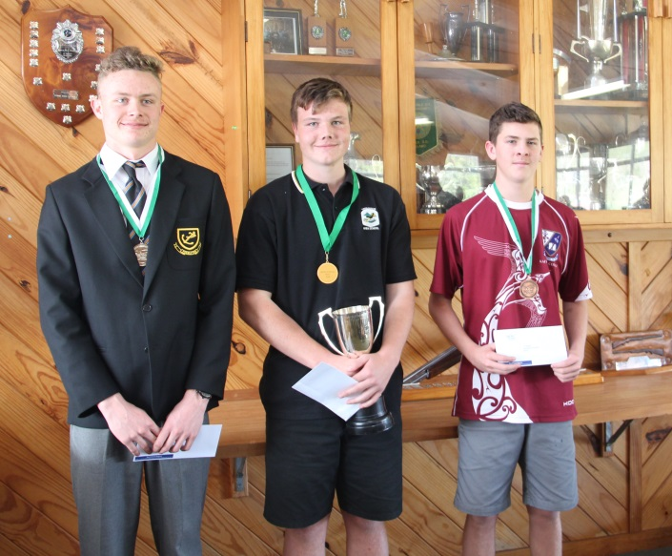

**1st Skye Martinac 447**

**2nd William Hamlin 430**

**3rd Taz Snelling 422**