COUNCIL REPORT
APRIL 2017

Sedimentation of South Otago Streams

Introduction

Many South Otago streams are continuing to experience sedimentation and nutrient run off from intensive agriculture practices resulting in degraded invertebrate and fishery health (ORC 2011, Hayes and Young 1999, Ramezani et al 2016). Sediment has been identified as a major stressor of stream health (Burdon et al 2013, Ramezani et al 2014, Matthaei et al 2010). High levels of sedimentation reduce salmonid egg and embryo survival (Bowerman, et al 2013, Quinn 2011). Major sources of sedimentation in intensively farmed catchments include runoff from winter cropping (Orchiston et al 2013) and bank erosion caused by intensive stocking of waterways (Holmes et al 2015, 2016). Best practice management of a winter crop paddocks such as longitudinal grazing and buffer swales can reduce sediment loss 10 fold from approximately 6000 kg to 600 kg (Orchiston et al 2013). Stock exclusion and the use of appropriate riparian margins along waterways can also significant reduce sedimentation levels (Holmes et al 2015).

Wairuna Case Study

Water quality in many tributaries of the Pomahaka has been deteriorating for several decades while land use has rapidly intensified (Young 1999, ORC 2011). The Wairuna Stream experiences particularly poor water quality and degraded invertebrate and fishery values largely related to intensive farming (Ramezani et al 2016). This includes bank erosion from heavy stocking resulting in high levels of sediment and nutrient run off (ORC 2011) and winter cropping runoff. Much of the mainstem Wairuna and its smaller tributaries are smothered in sediment (ORC 2011). In a 2010 ecological review of the Pomahaka tributaries it was noted that ‘the Washpool and Wairuna streams were the most degraded sites. The Washpool stream was smothered with 100 % fine sediment, which in some places was at depths of 15 cm. The Wairuna stream also had higher proportions of fine sediment cover (98%) despite it being a bedrock stream’ (ORC 2011). To further compound habitat degradation issues much of the Wairuna catchment has been channelised and dredged. Waterways in this catchment continue to be smothered in sediment and excavated on a regular basis to prevent blockage of tile drainage systems. There is no indication of a meaningful improvement in water quality in streams such as the Wairuna (LAWA 2017). Until land use practises and water quality in tributaries is improved the values of the regionally important Pomahaka River trout fishery will remain compromised (Hayes and Young 1999).

The situation in the Wairuna catchment is symptomatic of much of South Otago. Some farmers are making a concerted effort to improve land management such as those in the Pomahaka Watercare Group. However there remains reluctance from others to acknowledge significant improvements in winter cropping and buffer fencing are required. Cultivation and bank pugging continue to result in high levels of sediment loss to waterways. This is disappointing given there have been annual compliance visits to all dairy farms by ORC for at least 15 years now, as well as periodic community meetings aimed at improving farming practises. Despite these efforts cultivated land where riparian buffers are absent or inadequate (see appendix) and examples of bank erosion and pugging caused by stock in waterways remain commonplace.

Relevant Water Quality Rules - Plan Change 6A – Otago Water Plan

- When disturbing land you must put in place some measures to control sediment runoff into waterways. Having no sediment control measure is a prohibited activity (Rule 12.C.0.3).

- Sediment runoff (at all flows) from land into waterways must not result in:
  - a conspicuous change in colour or visual clarity, or a plume
  - a noticeable increase in local sedimentation (Rule 12.C.1.1).

- From April 2020 water nutrient thresholds in addition to the sediment or turbidity rule (12.C.1.1) will apply for any water discharge leaving an individual’s property. The nutrient thresholds in Schedule 16 only apply at or below median flow levels.

- Excavation/sediment clearance works in modified rivers (including rivers/streams that have been straightened and now resemble farm drains) requires resource consent.

Schedule 15 Limits

Water quality limits have also been set in Schedule 15 for mainstem rivers. These are designed to identify catchments with water quality issues where land management improvements are required. The limits are achieved when 80% of samples collected, at or below median flow, over a rolling 5-year period, meet or are better than the limits. A turbidity level of 5 NTU has been set for the Wairuna Stream.

Regulatory Response Issues

- Landholders need to be actively moving towards meeting Schedule 15 limits and that is going to be challenging in some catchments. For example turbidity levels in the Wairuna are 13.18 NTU and the limit is 5 NTU. Nitrogen (NNN), phosphorous (DRP) and bacteria levels (E.coli) also exceed Schedule 15 limits (ORC 2016).

- Just what constitutes an acceptable measure to reduce/stop sediment loss from disturbed land such as winter cropping is not described. The rule does not mention standards but landholders need to be given a clear steer on what is considered adequate to control sediment loss and what is not.

- Most sediment run off occurs during heavy rain and high flow events when receiving waterways are already discoloured. Although rule 12.C.1.1 applies to rivers at all flows, monitoring of these events is difficult and cannot be mixed in with routine monitoring activities. During heavy rain slugs of sediment progress down catchments to fill interstitial spaces in river gravels and smother stream beds.

- Water nutrient thresholds for discharges leaving private properties will not apply unless the receiving stream is at or below median levels.

- There continues to be cultivation of land and grazing of winter crops with inadequate mitigation in place and when it rains heavily this practise results in sedimentation of waterways (see appendix). This would appear to not meet the criteria of rule 12.C.1.1. Mitigation action needs to be more than a token effort.

- An additional issue is that some farmers are applying for consent to allow continued excavation of waterways. If these consents are approved without addressing the source of the sedimentation no improvements in downstream stream health will be realised. This was not the intention of Water Plan Change 6A. Also mechanical excavation of waterways can result in the loss of spawning gravels, the mobilisation of sediment and the creation of homogenous channels that have little refuge habitat for fish life.

What is Required?

A fundamental improvement in intensive farming practises is required if water quality, stream health and fishery values are to be protected from sediment pollution. This can only be achieved by a coordinated response involving education, leadership and strong regulatory action from the statutory governing body (ORC). The first priority should be to stop overland sediment runoff to waterways occurring in the first place. This requires significant mitigation in terms of adequate riparian margins, strategic grazing of winter crops and uncultivated swales to receive overland flow. It will also require acceptance that in some steeper hill country sediment loss cannot effectively be captured without exceptional mitigation efforts and therefore this land type is unsuitable for winter cropping and heavy grazing/pugging.

A minimum riparian buffer of at least 5 m from intensive farmland (Holmes 2016) is recommended as a starting point for discussion on flat terrain. High risk activities such as winter cropping on undulating country will require more, as well as buffer swales. Innovative measures such as sediment traps, treatment wetlands and two stage drainage systems to capture sediment run off should also be investigated.

Recommendations

That this report is received

That Council write to ORC outlining the concerns raised and request they address land use activities that continue to result in the sedimentation of South Otago streams, particularly the risks posed by winter cropping.

Morgan Trotter
Otago Fish and Game Officer

References

Bowerman, T., Bethany, T.N. and Budy, P. 2014. Effects of Fine Sediment, Hyporheic Flow and Spawning Site Characteristics on Survival and Development of Bull Trout Embryos. Canadian Journal of Fishery and Aquatic Science 71 pp 1059 -1071

Burdon, F.J., McIntosh, A.R. and Harding., J.S. 2013. Habitat Loss Drives Thresehold Response of Benthic Invertebrate Communities to Deposited Sediment in Agricultural Streams. Ecol. Appl. 23, 1036 -1047.

Hayes., J and Young, R. G. 1999. Trout Energetics and Effects of Agricultural Land Use on the Pomahaka Trout Fishery, Cawthron Institute. Cawthron Report No. 455

Holmes, R., Allen, C. and Goodwin, E. 2015. Riparian and Tuna Habitat Quality in the Tributaries of Waituna Lagoon, Southland. Prepared for DOC/Fonterra Partnership: Living Water Program. Cawthron Institute. Report No. 2587.

Holmes, R., Hayes, J., Matthaei, C., Williams., M. and Goodwin., E. 2016. Riparian Management Affects Instream Habitat Condition in a Dairy Stream Catchment. New Zealand Journal of Marine And Freshwater Research, 2016

LAWA 2017 Land Air Water Aotearoa website:
https://www.lawa.org.nz/search?argument=waiwruna

Matthaei, C. D., Piggott, J. J. and Townsend, C. R. 2010. Multiple Stressors In Agricultural
Streams: Interactions Among Sediment Addition, Nutrient Enrichment And Water
Abstraction. Journal Of Applied Ecology, 47, 639-649.

Otago Regional Council. 2011. Effects of Land Use on Water Quality in the Pomahaka Catchment. ISBN 978-0-478-37608-1

Otago Regional Council. 2016. Water Quality for the Pomahaka Report Card. http://www.orc.govt.nz/Publications-and-Reports/Farming-and-Land-Management/Water-Quality/Water-Quality-report-card-Pomahaka/

Orchiston, T.S., Monaghan, R.M. and Laurenson S. 2013. Reducing Overland Flow and Sediment Losses From Winter Forage Crop Paddocks Grazed by Dairy Cows
AgResearch, Invermay Agriculture Centre, Private Bag 50034, Mosgiel, New Zealand

Quinn, T.P. 2011. The Behaviour and Ecology of Pacific Salmon and Trout. UBC Press.
University of Wasington.

Ramezani, J., Rennebeck, L., Closs, G. P. and Matthaei, C. D. 2014. Effects of fine sediment
addition and removal on stream invertebrates and fish: a reach-scale experiment. Freshwater
Biology, Freshwater Biology 59 pp 2584 – 2604

Ramezani, J., Akbaripasan, A., Closs, G. P. and Matthaei, C. D. 2016. Instream Water
Quality, Invertibrate and Fish Community Health Across a Gardient of Diary Farming
Prevalence in a New Zealand River Catchment. Limnologica 61 Pp14-28

Appendix. Examples of winter cropping (August 2016) with ineffective buffers

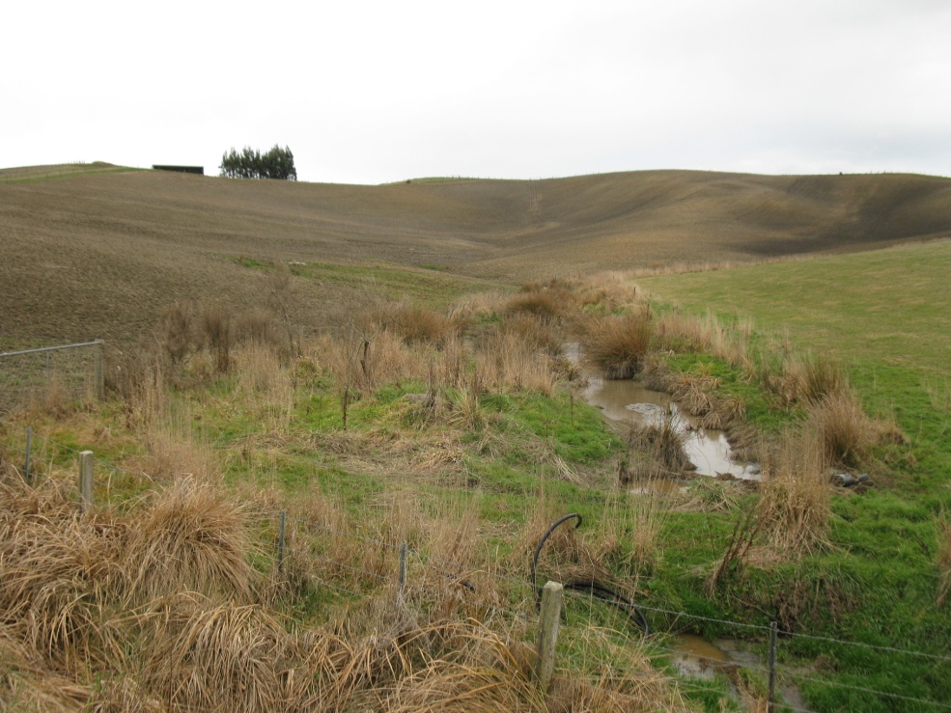

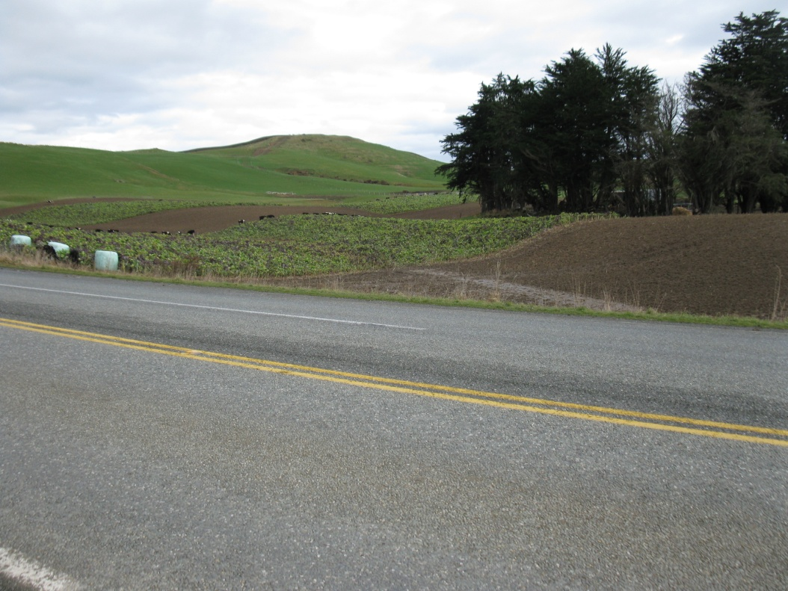

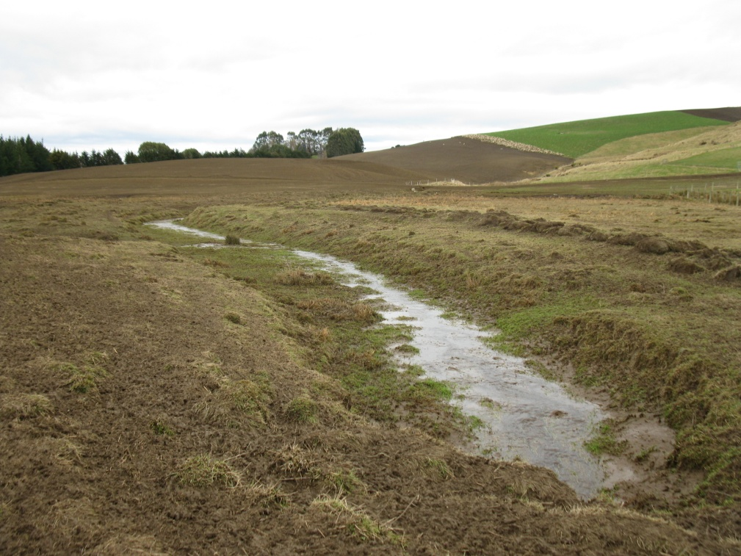

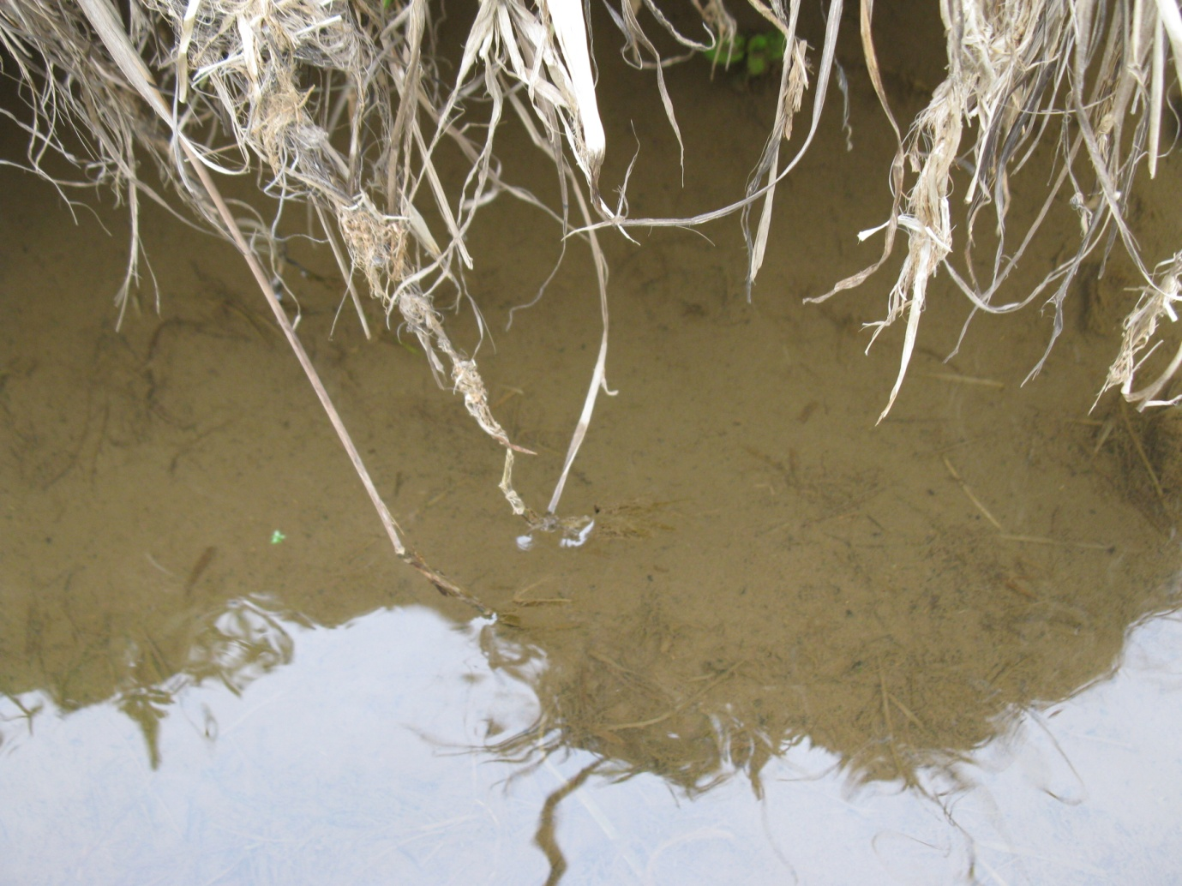

Receiving waterway from the photo above

