Analytical Report

New Zealand Fish and Game Council
PO Box 13141
Johnsonville, Wellington 6440

Date received: 15/05/2018 Time received: 09:30 am

Site Test: culture Results Units
___________________________________________________________________________
ARS1-Water Escherichia coli 45 CFU/100ml

___________________________________________________________________________
ARS1-Sediment Escherichia coli 230 CFU/100ml

___________________________________________________________________________
ARS2-Water Escherichia coli 440 CFU/100ml

___________________________________________________________________________
ARS2-Sediment Escherichia coli 730 CFU/100ml

___________________________________________________________________________
RRS1-Water Escherichia coli 175 CFU/100ml

___________________________________________________________________________
RRS1-Sediment Escherichia coli 273,300 CFU/100ml

___________________________________________________________________________
RRS2-Water Escherichia coli 20 CFU/100ml

___________________________________________________________________________
RRS2-Sediment Escherichia coli 7,100 CFU/100ml

___________________________________________________________________________
SRS1-Water Escherichia coli 160 CFU/100ml

___________________________________________________________________________
SRS1-Sediment Escherichia coli 230 CFU/100ml

___________________________________________________________________________
SRS2-Water Escherichia coli 10 CFU/100ml

___________________________________________________________________________

Site Test: cultures Results Units
___________________________________________________________________________

SRS2-Sediment Escherichia coli 200 CFU/100ml

Test: cultures | Methodology
Escherichia coli | USEPA 1603

Results of PCR analysis:

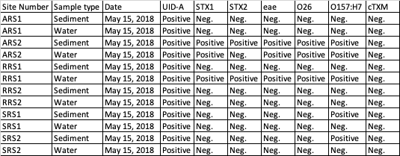

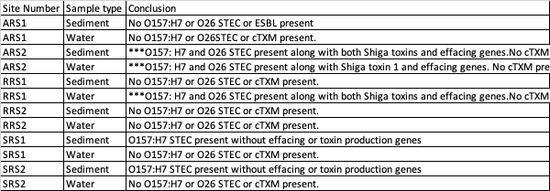

Abbreviations: Neg.= Not present in sample
Positive= present in sample
UID-A= β-glucuronidase for identification of Escherichia coli (not present in most O157:H7 strains)
STX1= Shiga toxin 1
STX2= Shiga toxin 2
eae= effacing and attachment gene necessary for intimate attachment to epithelial cells.
O26= STEC serotype (second most prevalent)
O157:H7 = STEC serotype (most prevalent)
cTXM = cTX-M, extended-spectrum beta-lactamase associated with resistance to antibiotics.
*** = sites with significant findings

Analytical Report

New Zealand Fish and Game Council
PO Box 13141
Johnsonville, Wellington 6440

Date received: 26/09/2018 Time received: 09:30 am

Site Test: cultures Results Units

ARS1-Water Escherichia coli 20 CFU/100ml

___________________________________________________________________________
ARS1-Sediment Escherichia coli 400 CFU/100ml

___________________________________________________________________________
ARS2-Water Escherichia coli 2,000 CFU/100ml

___________________________________________________________________________
ARS2-Sediment Escherichia coli 3,600 CFU/100ml

___________________________________________________________________________
RRS1-Water Escherichia coli 40 CFU/100ml

___________________________________________________________________________
RRS1-Sediment Escherichia coli 1,600 CFU/100ml

___________________________________________________________________________
RRS2-Water Escherichia coli 20 CFU/100ml

___________________________________________________________________________
RRS2-Sediment Escherichia coli 5,000 CFU/100ml

___________________________________________________________________________
SRS1-Water Escherichia coli 2,250 CFU/100ml

___________________________________________________________________________
SRS1-Sediment Escherichia coli 12,200 CFU/100ml

___________________________________________________________________________
SRS2-Water Escherichia coli 505 CFU/100ml

___________________________________________________________________________
SRS2-Sediment Escherichia coli 200 CFU/100ml

Test: cultures | Methodology
Escherichia coli | USEPA 1603

Results of PCR marker analysis:

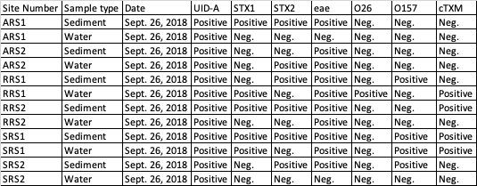

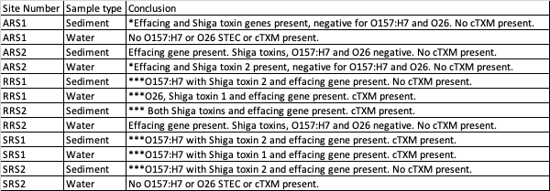

Abbreviations: Neg.= Not present in sample
Positive= present in sample
UID-A= β-glucuronidase for identification of Escherichia coli (not present in most O157:H7 strains)
STX1= Shiga toxin 1
STX2= Shiga toxin 2
eae= effacing and attachment gene necessary for intimate attachment to epithelial cells.
O26= STEC serotype (second most prevalent)
O157:H7 = STEC serotype (most prevalent)
cTXM = cTX-M, extended-spectrum beta-lactamase associated with resistance to antibiotics.
*** sites with significant finding
* sites with one or more Shiga toxins and effacing and attachment gene present. Further testing for other O serotypes would benefit these sites if wanting to rule out STEC.

Notice of Confidential Information:
If you receive this report in error, please notify the sender immediately. The information contained in this report is legally privileged and confidential. Unauthorised use, dissemination, distribution or reproduction of this report is prohibited.

