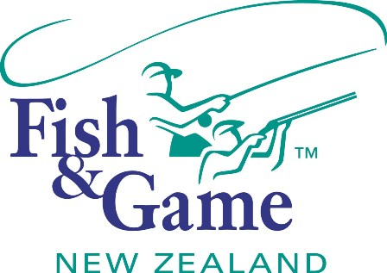
Mini Grey Valley Duck Hunt

Ikamatua; 11th & 12th July 2020

It’s on again: Due to the success of previous events, continued demand by hunters, high gamebird numbers and landowners requests, the Grey Valley Duck Hunt will be held again this season.
The reason we are organising the hunt is two-fold. Firstly it is to add value to your gamebird hunting licence by providing a venue and coordinated access to hunting opportunities in the central Grey Valley. A secondary goal is to send a message to the farming community that Fish & Game are responsive to concerns about gamebird population levels and the best way to manage concentrations of birds is by hunting during the normal game season.

The decision to return to the Ikamatua area has been based on the results of moult trend counts that indicate a better than healthy population of gamebirds, in particular Parries, in the Grey Valley.

Although parries remain the focus, the name of the event “Grey Valley Duck Hunt” hopefully encourages hunters to take advantage of other gamebird hunting opportunities like Mallards, Greys and Pukeko.

Hunting area: It is proposed at this stage to concentrate on the central Grey Valley, around Totara Flat and Atarau.

Coverage: The success of an organised hunting event depends on the distribution of hunters. Applying hunters will be coordinated by Fish & Game to facilitate the best coverage possible of the hunting area. F&G will retain control of the allocation of teams to areas this year.

Applications: All applications must come to Fish & Game. Following the close of applications on Friday 26^{h} June you will be sent confirmation if your application was successful, your allocated farm block, a map to show you where the property is, and other relevant information. All farmers will know that the shoot is on and there is no need for contact with them until your area is confirmed.
This year numbers will be capped at 80 hunters/ 20 teams and West Coast licence holders will get preference.

Organisation: Hunting can begin any time after daylight on Saturday 11th July. Further information around socialising will be announced to successful applicants in the email following applications closing on the Friday the 26th June.

If you require further information please contact:

Baylee Kersten
Fish & Game NZ - West Coast Region
Phone: 027 264 2805
E-mail: bkersten@fishandgame.org.nz


Grey Valley Duck Hunt Application Form

Maximum of four person teams. All participants must have a game bird hunting licence for the event. The first team member will be deemed to be the team leader and responsible for distribution of information to other members. They will also be expected to supply information regarding the number of birds shot by the team to F&G at the conclusion of the hunt. Individuals are encouraged to apply and could be included in an incomplete team.
Team Leader |  |  |  | Team Member 2
Name |  |  |  | Name
Address |  |  |  | Address
Telephone |  | Licence Number |  | Telephone | Licence Number
Team Member 3 |  |  |  | Team Member 4
Name |  |  |  | Name
Address |  |  |  | Address
Telephone | Licence Number |  |  | Telephone | Licence Number

TEAM NAME.......................................................................……………. (be original!)

Please complete the application form and return by Friday, 26th June to:

bkersten@fishandgame.org.nz

or

Fish & Game NZ - West Coast Region: PO Box 179
HOKITIKA

